East West University
Task 2-Supervised Pre-trained Baselines

Submitted By-
Name | Student ID
Sheikh Hossain Bin Bakhtiar | 2023-1-60-060
Shawna Akter | 2023-1-60-071
Bushra Khan Zilik | 2023-1-60-087
Humaira Habib Usha | 2023-1-60-022

Couse Code-CSE366
Course Name-Artificial Intelligence
Section-1
Semester-Fall 2026

Submitted to-
Dr. Raihan Ul Islam
Associate Professor
Department of Computer Science and Engineering

Date of Submission: 21st February,2026
1.Overall Performance Comparison:
Metric | VGG19 | VGG16 | Xception
Overall Accuracy | 98% | 97% | 86%
Macro Average  (Precision/Recall/F1) | 99% | 98% | 87%
Weighted Average  (Precision/Recall/F1) | 99% | 97% | 84%
Testing Time | 197.69 minutes | 160.03 minutes | 145.54 minutes

2.Class ways Performance:
MildDemented:
 | VGG19 | VGG16 | Xception
Precision | 99% | 99% | 84%
Recall | 98% | 100% | 83%
F1 Score | 99% | 99% | 83%
Class Accuracy | 98% | 99% | 83%

ModerateDemented:
 | VGG19 | VGG16 | Xception
Precision | 100% | 100% | 98%
Recall | 100% | 100% | 98%
F1 Score | 100% | 100% | 98%
Class Accuracy | 100% | 100% | 98%

NonDemented:
 | VGG19 | VGG16 | Xception
Precision | 98% | 95% | 83%
Recall | 99% | 99% | 91%
F1 Score | 99% | 97% | 87%
Class Accuracy | 99% | 98% | 91%

VeryMildDemented:
 | VGG19 | VGG16 | Xception
Precision | 99% | 98% | 86%
Recall | 98% | 93% | 74%
F1 Core | 98% | 96% | 79%
Class Accuracy | 98% | 93% | 73%

3. Confusion Matrix Comparison:
VGG19:
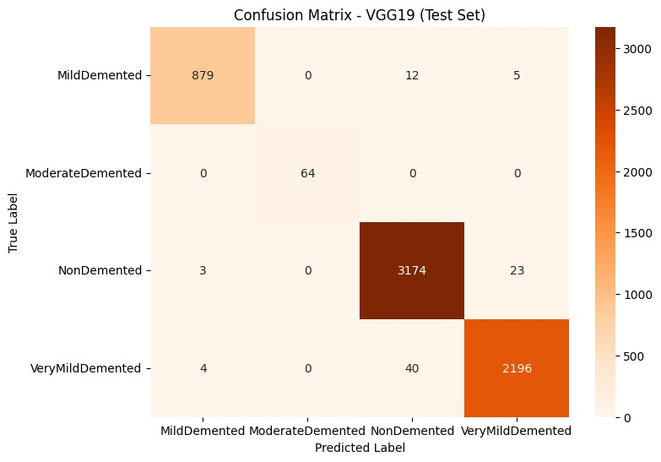
VGG16:
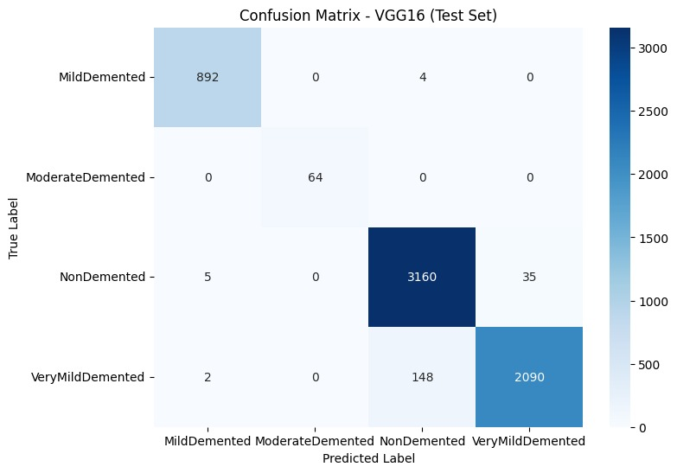
Xception:
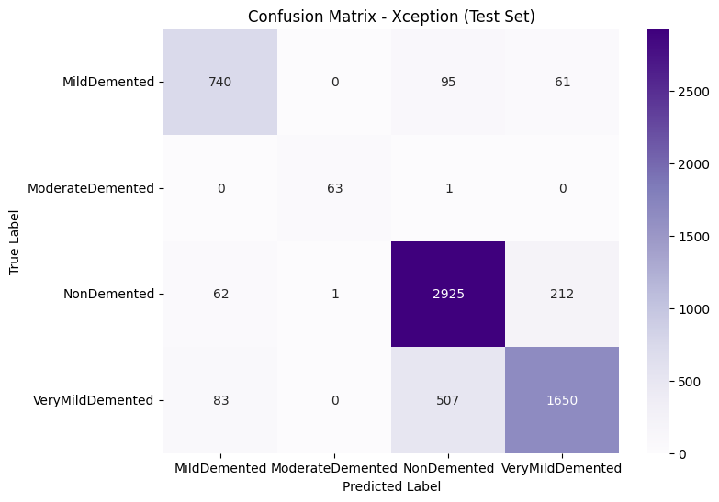

4.ROC Curve Comparison:
VGG19:
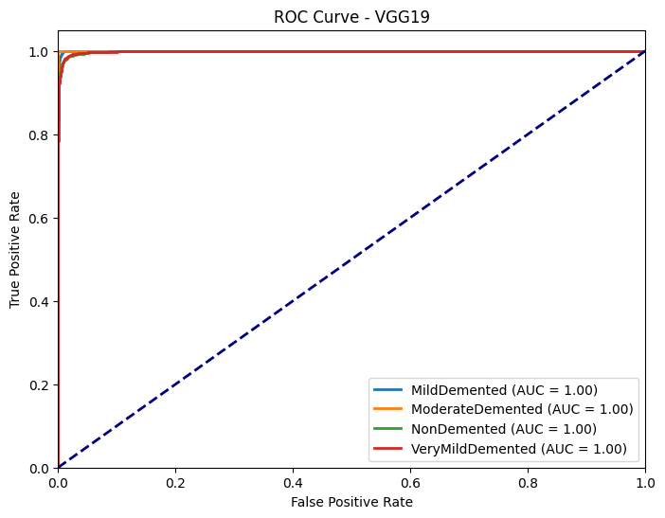

VGG16:
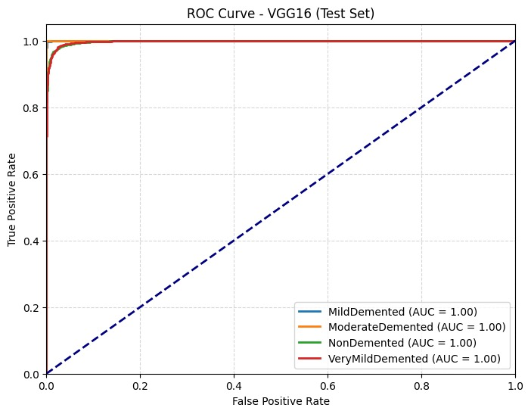

Xception:
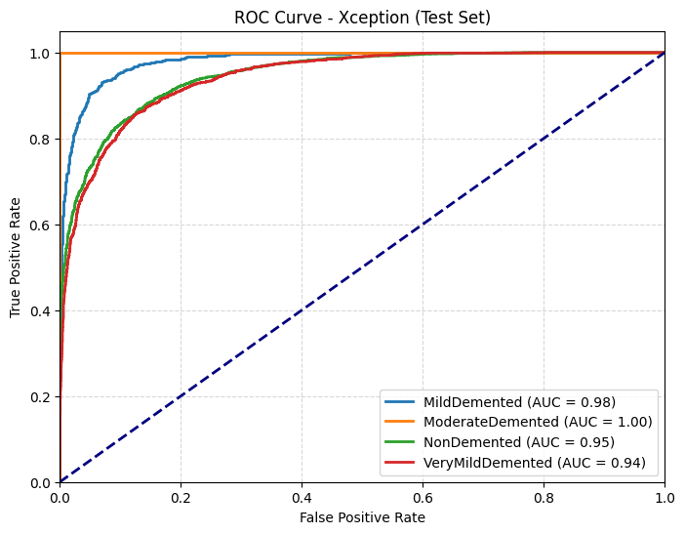

Paired T-tests
Comparison | T-Statistic | P-Value | Superior Model
VGG16 vs VGG19 | -6.7237 | < 0.001 | VGG19
VGG16 vs Xception | 26.5441 | < 0.001 | VGG16
VGG19 vs Xception | 30.9178 | < 0.001 | VGG19

